**Dyson Global Dust Study 2023: Indians show high awareness regarding the presence of viruses on pets, yet only 1 in 4 pet owners prioritise cleaning their homes every day**

*Dyson Microbiologists shed light on the correlation between being a pet owner, household dust, cleaning habits and the potential implications on our overall well-being.*

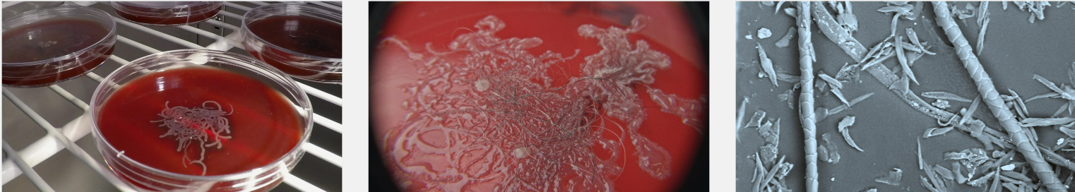

***India, January 3, 2024:*** India’s pet care industry is experiencing remarkable growth, as pets increasingly become cherished members of the family. In fact, almost ***one in every six Indians now has a pet***, with dogs being the most beloved companions. There has been even more growth in India, where the pet care industry has grown at 16.5% yearly. It is estimated that the Indian market will grow to a big $1,932.6 million by 2030. But with pets come pet hair, dander, and skin flakes. This introduces a new set of challenges when it comes to maintaining cleanliness. The Dyson Global Dust Study 2023[[1]](#footnote-0) investigates cleaning habits and behaviours and delves into the *understanding of household dust and the potential impact it can have on our well-being.*

Every pet parent understands the challenges of keeping a clean home for the well-being of every family member as well as the overall environment of the home. However, the Dyson Global Dust Study 2023 *states that* ***only 1 in 10 pet owners overall feels guilty about neglecting cleaning tasks****. It highlights a disconnect between acknowledging the importance of cleaning and implementing regular cleaning habits. By further investigating their cleaning habits,* ***it is revealed that despite a high level of awareness among pet owners in India about the potential presence of viruses in their homes, only 27% of them consistently engage in cleaning every day.***

**A closer look at cleaning habits of pet owners in India**

* Only **28%** of pet owners take complete responsibility for cleaning their homes
* Only **21%** of pet owners include cleaning their pet baskets as part of their general cleaning routine
* **41%** pet owners believe that household dust can contribute to allergies such as pet allergens, pollen, and dust mites
* **3 in 10** Indians are the most relaxed about letting their dogs sleep on their beds as well as the bedroom floor.

**Monika Stuczen, Research Scientist in Microbiology at Dyson, says,** *"Many people think that pet hair is the biggest problem as it is the most visible. Unsurprisingly, people are unaware of the other particles that may reside on their pets because these particles tend to be microscopic in size”.*

People often think that pet hair triggers allergies. However, allergies are triggered by allergens that can also be found in pet dander.

According to the Dyson Global Dust Study 2023, in India, **42% allow their pets on their sofas**, unaware of the fact that they leave dander around the home consisting of tiny flakes of skin, fur, or feathers, which can harbour viruses and other allergens which is a concern.

Regular vacuuming only reduces the amount of pet hair they shed around the home, but microscopic particles remain on their pets that can potentially be spread around the home. If you have a pet, consider what they bring in when they come in and where they shed in your home. It’s also important to remember that short-haired or hairless animals contribute dander and allergens to indoor air pollution just as effectively as long-haired animals.

“It is a cause for concern if people only clean when they spot visible dust on the floors as many dust particles are microscopic in size,” says Monika. “In fact, by the time people spot visible dust in the home, it is highly likely that there are dust mites in your home.”

**Dyson Pet groom tool: A game-changer for Indian pet owners in tackling pet hair woes**

The Dyson Global Dust Study 2023 says that a lower percentage of pet owners, only **31%,** prioritise their concerns around animal/pet hair during the cleaning process, which can potentially lead to several health issues.

Pet hair and dander *(dead skin flakes)* can cause allergic reactions in Humans. Even for those without allergies, excessive pet hair and dander can cause discomfort and respiratory issues due to the dust particles they carry.

***Dyson, being the leader in pet science,*** offers a ***"Pet Groom Tool" for mess-free grooming.*** Engineered to provide respite to the challenges around pet hair, the revolutionary tool allows pet parents to brush loose hair off their pets and directly into the Dyson cord-free vacuum cleaners.

It is a true game changer for Indian pet owners and is specifically suitable for dogs and cats with medium and long hair. Both species shed a lot of hair depending on the season and breed, so instead of constantly vacuuming your home and removing all the falling hair, the Dyson Pet groom tool is a useful accessory that allows you to address the issue at its root.

**Are people cleaning the right spaces in their homes – with the right methods?**

Year-on-year, we see positive shifts in people’s cleaning habits. More people are vacuuming some of the commonly overlooked spaces including their mattresses and sofas when cleaning their homes. **Indians possess the highest level of awareness** regarding the presence of viruses in dust, with a staggering 50% of the population being knowledgeable about this fact. However, it is worth noting that the APAC region generally lacks awareness about the presence of skin flakes in dust.

At Dyson, our research shows us that the best way to tackle dust allergens is to remove them from the home completely.

“*Using a wet cloth to clean surfaces is fine, but the sequence of cleaning tools matters. Dampening dust on floors without removing them could mean that you’re creating a habitat more favourable to dust mite and mould proliferation,”* explains Monika.

Therefore, at Dyson, we’ve spent almost 20 years studying real dust – only by understanding the complex matrix of household dust can we better enable our vacuum cleaners to deal with the conditions they face in real homes. Our engineers spend a lot of time developing our filters and seals to make sure that we capture not only the dust you can see but also the dust you can’t. We want to make sure that what has been sucked up remains trapped in the bin and is not expelled back into your home – helping to keep your home clean and hygienic.

**Some facts about pet hair and dander:**

**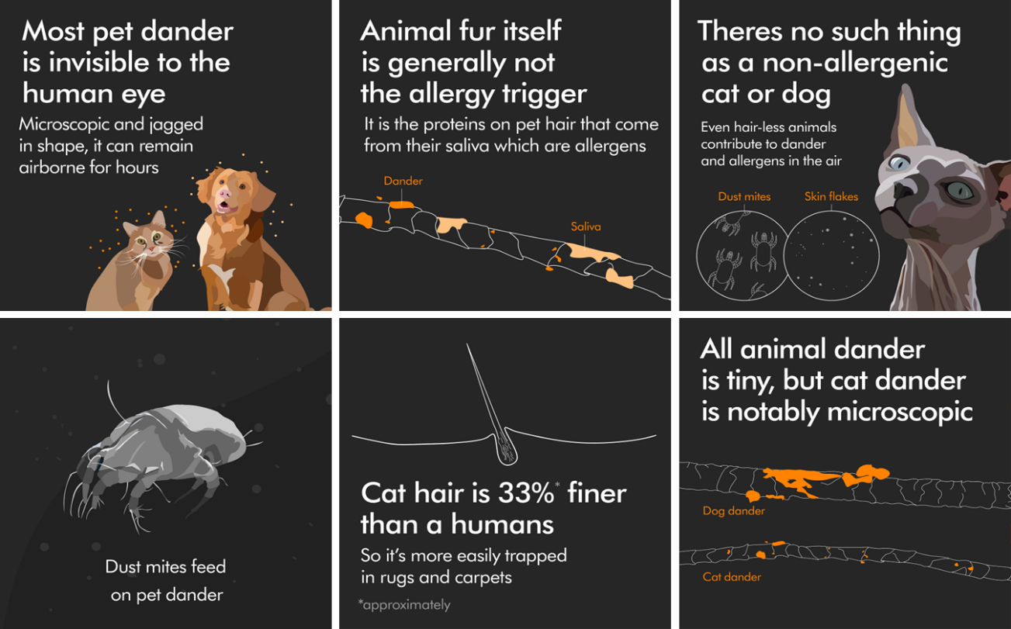**

**END**

**Notes­­ to editors**

**ABOUT THE DYSON GLOBAL DUST STUDY 2023**

The Dyson Global Dust Study 2023 is a 15-minute online survey undertaken by 33,997 respondents across 39 countries. Fieldwork was conducted between the 11th of January to 6th February 2023 and data has been weighted at a ‘global’ level to be representative of different population sizes.

**DYSON TECHNOLOGY**

* [Dyson V12s Detect Slim Submarine™](https://www.dyson.in/products/cord-free/dyson-v12s-detect-slim-submarine/overview) : Dyson first wet and dry vacuum cleaner is designed to tackle various cleaning challenges, from dust and spills to stubborn stains. With a wet roller head and an eight-point hydration system, it effectively cleans up wet messes, while a motor-driven microfiber roller takes care of tough stains and debris. The vacuum cleaner features Dyson's 2x illuminating dust technology, ensuring that even the tiniest particles don't escape its cleaning prowess. Moreover, the included Hair screw tool makes it ideal for households with long hair or pets, as it efficiently collects hair without tangling around the brush.
* [Dyson V15 Detect™](https://www.dyson.com/vacuum-cleaners/sticks/dyson-v15-stick/overview" \t "_blank)cord-free vacuum: A new generation of cord-free vacuum cleaners, launched in March 2021, feature an illuminated cleaner head that reveals hidden dust, while an acoustic piezo sensor measures and records the dust and debris that has been sucked up.
* [Dyson V12™ Detect Slim](https://www.dyson.in/products/cord-free/dyson-v12-detect-slim-vacuums/overview) cord-free vacuum: Dyson's lightest cord-free vacuum with Illumination and dust detect technology. The vacuum technology in a compact machine weighing just 2.2kg, for easier cleaning all around the home. Laser reveals microscopic dust. Captures up to 99.99% of particles as small as 0.3 microns.
* [Dyson V11™ Absolute Pro cord-free vacuum](https://www.dyson.in/dyson-v11-absolute-nickel-blue-cord-free-vacuum-with-swappable-battery): The Dyson V11 is a remarkable cord-free vacuum cleaner that offers convenience and powerful performance. With its sleek and futuristic design, resembling a science-fiction-inspired gun, this vacuum is made primarily of plastic and features a large transparent dustbin. Equipped with swappable battery packs, the machine offers an extended run time of up to 120 minutes, ensuring fade-free cleaning throughout.
* [Dyson V8 Absolute](https://www.dyson.in/products/cord-free/dyson-v8/overview) cord-free vacuum: This vacuum is known for its powerful suction, versatility, and low noise operation. It is equipped with innovative de-tangling technology, which helps prevent hair and debris from getting tangled in the brush bar, ensuring uninterrupted cleaning performance.

1. 33,997 online interviews across a representative sample of 39 countries. Fieldwork was conducted between 11th January and 6th February 2023. Data has been weighted at a ‘Global’ level to be representative of different population sizes. [↑](#footnote-ref-0)